Unit 11: Traveling around Viet Nam

***Section: Getting started – Listen and read***

1. **Getting started:**

Work with two classmates. Match the places of interest in Viet Nam with their names.

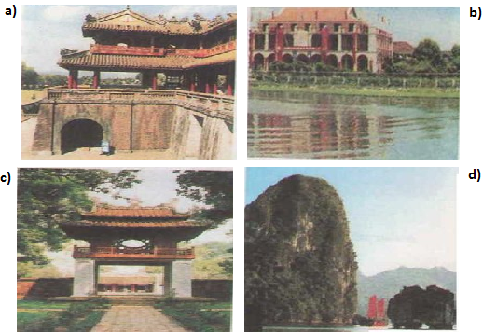

**a)** Ngo Mon (Gate): Cổng Ngọ Môn

**b)** Nha Rong Harbor: Bến Nhà Rồng

**c)** The Temple Literature: Văn Miếu - Quốc Tử Giám

**d)** Ha Long Bay: Vịnh Hạ Long

**B. Listen and Read**

**1. Practice the dialogue in groups.**

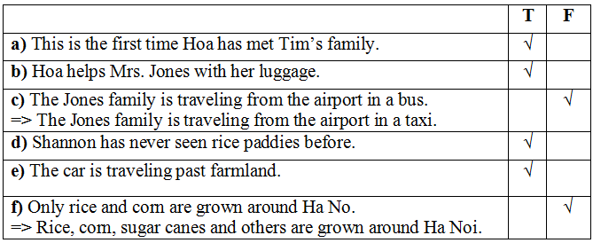**2. True or false? Check (√) the boxes. Then correct the false sentences and write them in your exercise book.**

***C. Exercise: Choose the letter A, B, C or D to complete the sentences***

**Question 1: -“ Would you mind lending me you bike?” – “ _____________.”**

A. Yes. Here it is

B. Not at all

C. Great

D. Yes, let’s

**Question 2: Are you interested __________ travelling around Vietnam?**

A. on

B. in

C. at

D. for

**Question 3: The Imperial Citadel of Thang Long is recognized as one of the World’s _______ by the UNESCO.**

A. Heritage

B. Tourist

C. Culture

D. Jungle

**Question 4: My younger sister _________ ten on her next birthday .**

A. will be

B. is

C. will

D. be

**Question 5: The cave is _________ magnificent that it attracts many tourists.**

A. enough

B. such

C. so

D. too

**2. A famous inventor, Dr. Kim, is going to build a time machine. One of his assistants, Hai, is asking him questions about the invention. Complete the dialogue. Use the correct form of the verbs in brackets.**

**Hai:** When (0) *will* the project *be started*, Doctor?

**Dr. Kim:** Very soon.

**Hai:** Many people want to see the time machine.

**Dr. Kim:** Yes. It (1) **will be shown** to the public when it is finished.

**Hai:** (2) **Will** it **be built** by the end of the year, Doctor?

**Dr. Kim:** I'm afraid not, but it (3) **will be finished** before Tet.

**Hai:** (4) **Will** it **be made** by you?

**Dr. Kim:** No, I need you to build it. When can you start?

**Hai:** Let's begin tomorrow.

**3. Complete the dialogues. Use the words in the box.**

Tiếng Anh 8 và giải bài tập tiếng Anh lớp 8

**a) Ba:** Turn right, then left, and the left again.

**Nam:** It's (0) *difficult to follow* your directions. Can you start again, please?

**b) Mr. Dao:** Can you do the exercise, Hoa?

**Hoa:** Yes, Mr. Dao. It's (1) **easy to understand**.

**c) Lan:** In the future, mankind might live on the moon.

**Nga:** Really? It's (2) **hard to believe**.

**d) Mrs. Thoa:** Stop, Tuan! It's (3) **dangerous to go** near the stove.

**Tuan:** Sorry, Mom.

**e) Hoa:** Should I stir the mixture, aunt Thanh?

**Aunt Thanh:** No. It's (4) **important to wait** for five minutes.

**4. Complete the letter. Use the correct forms of the verb *be* and the adjectives in the box.**

**happy     delighted     certain     relieved     sure     afraid**

*Dear Nam,*

Your grandfather and I (0) *are delighted* that you passed your English exam.

Congratulations!

Aunt Mai (1) **was happy** that you remembered her birthday last week. She told me you gave her a beautiful scarf.

I (2) **am relieved** that your mother is feeling better. Please give her my love.

We're looking forward to seeing you in June. However, grandfather (3) **is afraid** that the day is wrong. (4) **Are** you **sure** that you're arriving on Saturday 20th? I (5) **am certain** that there are no trains from Ha Noi on Saturday.

Write soon and confirm your arrival date and time.

*Love,*

*Grandma*